Leg Strengthening
Strength training is important for the major muscle groups of the body and should be progressive in nature i.e. increase the number of repetitions or increase the resistance over time. Aim to build up to two sets of 15 repetitions of each exercise and do strength training on two to three days per week. Never do an exercise if it causes pain and if feeling unsteady hold onto something with one hand or do the exercises in a lying position.

Straight Leg Raise
- While lying, raise up your leg with a straight knee.
- Keep both knees straight the entire time.
- Hold for five seconds
- Repeat 15 times
- Complete two sets
- Three times per week

Bridging
- While lying on your back with your knees bent, tighten your lower abdominal muscles, squeeze your buttocks and then raise your buttocks off the floor/bed, as if creating a "Bridge" with your body.
- Hold and then lower yourself and repeat.
- Hold for five seconds
- Repeat 15 times
- Complete two sets
- Three times per week

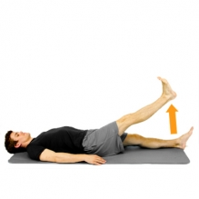

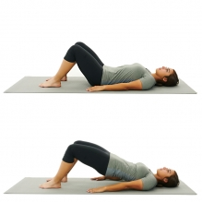

Squat
- Leaning up against a wall or closed door on your back, slide your body downward and then return back to an upright position.
- Knees should bend in line with the second toe, and not pass the front of the foot.
- If your balance is affected, try holding onto the back of a chair with both hands while doing the squats.
- Hold for five seconds
- Repeat 15 times
- Complete two sets
- Three times per week

Lunge
- Start by standing with feet shoulder-width apart.
- Next, take a step forward and slightly out to the side and allow your front knee to bend.
- Your back knee will bend as well. Then, return to the original position and repeat with the same leg.
- If your balance is affected try holding onto a chair beside you with one hand.
- Hold for five seconds
- Repeat 15 times
- Complete two sets
- Three times per week

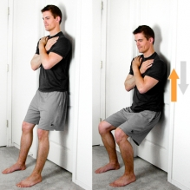

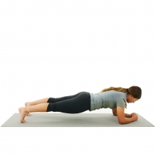
Plank – Core Strength
- While lying face down, lift your body up on your elbows and toes.
- Try and maintain a straight spine.
- Do not allow your hips or pelvis on either side to drop.
- Hold up to one minute
- Repeat five times
- Three times per week

If you need more specific advice and treatment for certain symptoms, ask your team in the Multiple Sclerosis (MS) Unit about accessing the physiotherapy service here in the hospital (Tel: (01) 416 2503) or ask your GP to refer you to your local primary care physiotherapist.

